LINCOLNSHIRE ICB
STANDARD OPERATING PROCEDURE
FOR THE USE OF
TELEHEALTH MONITORING RESIDENTIAL HOME
DIGITAL TABLET

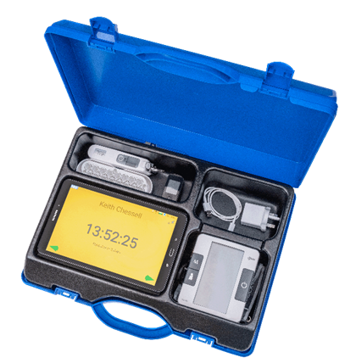

 | Contents
 | Definition of key terms |  |  | Page 2
 | 1. Introduction |  |  | Page 3
 | 2. Purpose and vision |  |  | Page 5
 | 3. Outline of the digital tablet and cloud based software |  |  | Page 5
 | 4. Roles and Responsibilities |  |  | Page 7
 | 5. Governance |  |  | Page 8
 | 6. Training |  |  | Page 9
 | 7. Managing Equipment |  |  | Page 10
 | Definition of key terms:
 | Abbey Pain Score |  | A measurement tool for pain for people with dementia who cannot verbalise.
 | Residential Home |  | Includes Residential care and Nursing Homes.
 | Cloud based system |  | A place where shared information is stored and shared to other professionals.
 | Digital Tablet |  | A wireless portable personal computer with touchscreen.
 | Health Care Professional |  | This would cover a range of health care professionals across the health care field including GP, Nurses, Geriatrician, and Dietician, pharmacist, paramedic, occupational therapist, and physio therapist.
 | Infection Prevention and Control (IPC) |  | Team to help you meet CQC requirements, reduce healthcare associated infection and hospital admission.
 | LinCA – Lincolnshire Care Association |  | LinCA aims to support and enable Professional Carer’s to deliver effective, sustainable services with quality, person-center outcomes for those who use them, and to respond in a dynamic way to changes in the wider health and care system.
 | Lincolnshire ICB -  Integrated care board |  | An NHS organisation which commissions health services for the population of Lincolnshire.
 | Multi Disciplinary Team |  | Collection of professionals from all sectors of health and social care to care plan patient needs from a holistic approach.
 | MUST– Malnutrition Universal Screening Tool |  | A 5-step screening tool to identify adults who are malnourished, at risk, or are obese.
 | NEWS2 - National Early Warning Score |  | A combination of 6 physiological measurements that determines clinical risk (NEWS2 table utilised)
 | Professional Carer |  | A Professional Carer is referred as the person providing care to the resident and for the purpose of the tablet will usually be the employed carer in the Residential or Nursing Home.
 | Resident |  | An individual residing in the Residential/Nursing Home setting.
 | SBARD  Situation, Background, Assessment, Recommendation and  Decision |  | SBARD consists of standardised prompt questions in five sections to ensure that staff are sharing concise and focused information. It allows staff to communicate assertively and effectively, reducing the need for repetition and the likelihood for errors.
 | Telehealth provider |  | Telehealth Monitoring creators
 | Telehealth |  | A solution providing with a means of collecting health information about residents using telecommunications to transmit the information. May be used to manage long term conditions.
 | Telehealth Monitoring Kit |  | Name of the Telehealth kit
1. |  | Introduction  The objective of this standard operating procedure is to provide guidance on the introduction and operational process of using Telehealth Monitoring, telehealth digital solution, within Residential Homes and with the EHCH MDT.  The Telehealth Monitoring kit should only be used when instructed by a Health Care Professional (1.2 and 1.3), unless a resident is showing signs of deterioration or has stated that they are unwell (1.4) when the results are shared with the Health Care Professional.  Consent must always be given, where consent cannot be given mental capacity assessment must be completed.
1.1 |  | Pathways – Driven by clinical need  The pathway triangle can start at any point and flow in either direction but cannot be broken and must be completed once started.
1.2 |  | Baseline Pathway - To record an essential health observation on a new resident or a resident returning from respite or hospital, maximum of 24 hours before MDT to set a baseline.
 |  | 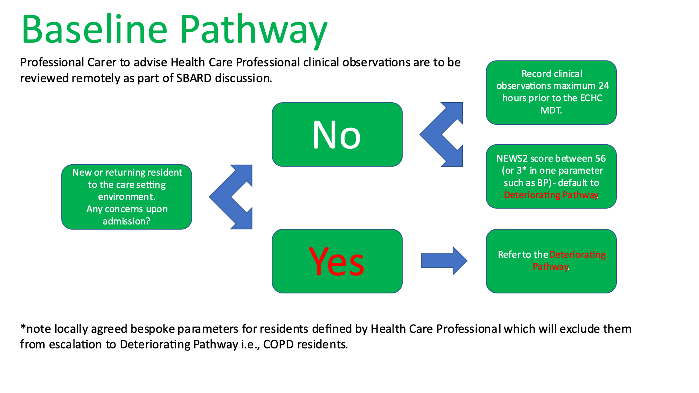
1.3 |  | Review Pathway, Clinical agreed review between Residential Home and PCN. For example, annual diabetic review, newly commencing medication, hypertension review
 |  | 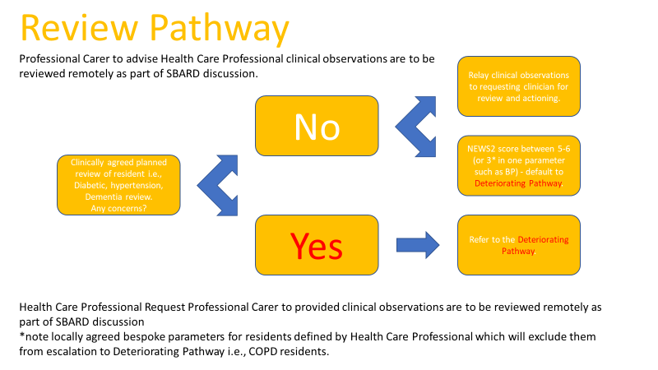
1.4 |  | Deteriorating Pathway, To seek clinical advice if a resident health has deteriorated utlising SBARD and Telehealth Monitoring to provide information to support the reviewing clinician decision. For example CAS,111,999
 |  | 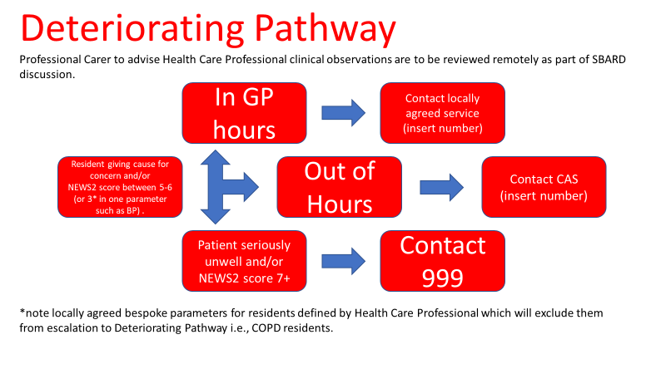
1.5 |  | The use of Telehealth Monitoring should not replace common sense judgement with regards to existing escalation protocols for unwell Residential Home residents requiring urgent attention.  Any ReSPECT plan or Advance Care and Plan in place must be followed.
2. |  | Purpose and vision
2.1 |  | To introduce Telehealth Monitoring into the Health and Social environments to enhance collaborative working to ensure a standardised assessment of clients improving clinical health outcome decision making.
2.2 |  | To provide guidance in Telehealth Monitoring implementation with the ability to standardise and audit:  - Professional Carer training and competency maintenance  - Health Care Professional remote access and responsibility to review data  - Governance i.e., IPC  - Use and maintenance of equipment  - Assessment tools i.e., NEWS2  - Escalation pathways
3. |  | Outline of the digital tablet and cloud-based software
3.1 |  | The digital tablet, used in Telehealth Monitoring, which incorporates software that can be used to monitor residents’ health and wellbeing. The tablet is provided with observational equipment,  - Sp02 Monitor (Oximeter) including Heart rate  - Blood pressure monitor including Heart rate  - Thermometer (additional thermometer caps can be ordered from LinCA)  Telehealth Monitoring has Bluetooth capability that transmits the readings directly to the tablet. Respiration rate observations need to be carried out manually, the relevant training is provided by TELEHEALTH MONITORING and LinCA (section 6).
3.2 |  | The tablet has the following elements incorporated  - 3.6 - Abbey Pain Score  - 3.7 - Is My Resident Unwell  - 3.8 - MUST - Malnutrition Universal Screening Tool  - 3.9 - NEWS2 - National Early Warning Score  - 3.10 - SBARD - Situation, Background, Assessment, Recommendation and Decision
3.3 |  | Other elements and equipment of the Telehealth Monitoring kit can be found in appendices A1 and A2 these elements and equipment can only be used following the instructions from the EHCH MDT or other Health Care Professional.
3.4 |  | Once the resident’s clinical observations are recorded on the digital tablet, utlise as per pathway 1.2, 1.3 and 1.4 Health Care Professional advise will be provided for the ongoing care of the resident.
3.5 |  | Abbey Pain Score  The Abbey Pain Scale is an instrument designed to assist in the assessment of pain in patients who are unable to clearly articulate their needs.
3.6 |  | Is My Resident Unwell  This communication tool assists staff in recognising signs and will assist in recording a set of observations of residents. The resource is a structured communication tool which looks at and records soft signs, to be used in conjunction with NEWS2.
3.7 |  | MUST  Is a five-step screening tool to identify adults, who are malnourished, at risk of malnutrition (undernutrition), or obese. It also includes management guidelines which can be used to develop a care plan and can be used by all care workers.
3.7.1 |  | Clinical Outcomes of MUST:  MUST promotes multidisciplinary care and responsibility, with consequent improvements in clinical outcomes. Early recognition of malnutrition risk, or deterioration in nutritional status and appropriate care pathway to ensure risk factors are acted upon. Better nutritional care for patients, resulting in reduction in the health risks associated with malnutrition.
3.8 |  | NEWS2  Uses six physiological measurements to determine the level of sepsis risk:  - Respiratory Rate  - Oxygen Saturations  - Systolic Blood Pressure  - Pulse Rate  - Level of Consciousness or new confusion  - Temperature
3.8.1 |  | A score is allocated to each parameter as they are measured, with the magnitude of the score reflecting how extreme the parameter varies from the norm. The score is then aggregated and uplifted by 2 points for people requiring supplemental oxygen to maintain their recommended oxygen saturation.  This is a pragmatic approach, with a key emphasis on system-wide standardisation and the use of physiological parameters that are already routinely measured in NHS hospitals and in prehospital care, recorded on a standardised clinical chart.
3.8.2 |  | This score is shared with a Health Care Professional so that early recognition of a deteriorating resident is established, and the appropriate support is given.
3.9 |  | SBARD (Situation, Background, Assessment, Recommendation and Decision)  Situation - Identify yourself, Identify the resident/client by name and the reason for the call, Describe your concern.  Background - What long-term illness does the resident/client have? Provide a list of current medication.  Assessment - What are the resident/clients’ vital signs, NEWS2 score and other relevant information? What actions (if any) have you taken already?  Recommendation - Explain what is needed – be specific about request and time frame.  Decision - What, When and How any decisions have been agreed based on the S-B-A-R, write down any instructions and remember to add a time and date when they had been requested, document any actions undertaken.
3.10 |  | If one or more of the elements from 3.3 are performed on the tablet, the following steps in alignment with the escalation tools 1.2, 1.3 and 1.4 must be completed, in line with a resident’s emergency health care plan where appropriate.
3.11 |  | Once all information is uploaded to Telehealth Monitoring cloud-based system, the Residential Home, alongside other Health Care Professional responsible for the resident’s care can access the information by logging on to the web-based portal and using their log in details and a secure password provided, or the Lincolnshire Care Portal (based on access rights).
3.12 |  | Login details can be provided by LinCA, along with training guides, as part of the initial induction training and as each new Residential Home, MDT or Health Care Professional.
4. |  | Roles and Responsibilities
4.1 |  | ICB  Providing ongoing support to enable the Residential Home and PCN to support the residents.
4.2 |  | Residential Home  It is the responsibility of the Residential Home is to:  - Book staff onto training with TELEHEALTH MONITORING and LinCA  - Maintain professional care competency  - Adherence to the pathway escalation process  - Ensure the kit is maintained, preventing avoidable damage and PAT test as required  - Complete necessary IPC audits
4.3 |  | Health Care Professional  It is the responsibility of Health Care Professionals whether as part of the MDT or as the triaging clinician of which a Telehealth Monitoring pathway is be utilised to:  - To discuss new residents admitted to the Residential Home setting via the EHCH MDT  - Review the resident’s baseline Telehealth Monitoring clinical readings  - Complete medication review accordingly  - Make appropriate onward referral to maintain resident’s needs/wishes  - To negotiate agreed reviews with the Health Care Professional for ongoing client Telehealth Monitoring monitoring  - Set bespoke parameters for Resident’s clinical observations i.e., COPD Resident’s  - Provide clinical guidance on Resident’s who can be excluded i.e., End of Life  - Review the Telehealth Monitoring data remotely for confirmation of reading and calculate NEWS2 score to assist in clinical judgement and escalation.  - The receiving Health Care Professional knows where to acquire the information from
4.4 |  | LinCA  It is the responsibility of LinCA is to:  - Single point contact for Telehealth Monitoring enquiries (Not clinical)  - Organise training and support providers where required  - Assist with the delivery and setup of Telehealth Monitoring
5. |  | Governance
5.1 |  | The equipment and operational aspect of the tablet have been quality and risk  assessed by TELEHEALTH MONITORING - The equipment is calibrated, and CE marked demonstrating adherence to quality standards. It comes with a 12-month statutory guarantee.
5.2 |  | Care of the Telehealth Monitoring Telehealth Kit  For details on how to clean the kit see appendix A3
5.3 |  | It is essential that the data collected is stored in a safe manner, in accordance with the Data Protection Act 1998.
5.3.1 |  | The Telehealth Monitoring cloud-based system in built, in accordance with this Act and provides a secure portal for all resident information.
5.3.2 |  | Information should only be shared with those authorised to receive that information including the Health Care Professional listed in section 2 of this document.
5.4 |  | Monitoring compliance – Monitoring the Telehealth tablet will be carried out within services when joint monitoring between the ICB and TELEHEALTH MONITORING is undertaken. This will ensure that the tablet is being used correctly to record information for residents and acted upon in a timely manner.  Review and engagement to work collaboratively to ensure best outcomes achieved for resident – please reference your PCN EHCH policy
6. |  | Training
6.1 |  | A training package has been developed and incorporates use of:  The digital tablet Telehealth Monitoring.  SBARD.  NEWS2 training.  physiological measurement training.  MUST training.  use of the Abbey Pain Score.
6.2 |  | Training is delivered virtually upon booking onto sessions available with LinCA or upon request
6.3 |  | The employer must ensure that staff who are using Telehealth Monitoring and undertaking the necessary clinical observations to complete SBARD, NEWS2, MUST and the Abbey pain score must attend the training program and be trained by TELEHEALTH MONITORING or LinCA.
6.4 |  | Only a Health Care Professional can interpret the Telehealth Monitoring observations and any assessment that has been completed
6.5 |  | Staff should use the equipment every 28 day to ensure that their competence is kept up to date, this can be done by staff taking other staff members readings as part of the “Know your numbers” program (Website links below), if a resident’s observation are not required.  https://www.nhs.uk/conditions/blood-pressure-test/  Know your numbers (Blood pressure UK)
7. |  | Managing Equipment
7.1 |  | Delivery of equipment to Residential Homes and support to all stakeholders is provided by LinCA
7.2 |  | Equipment should be stored, when not in use in the blue storage case, in the nominated secure area, dry and not damp, preferably a locked room, and plug the external power cable into the case to ensure the tablet is charged for the next use, only use the power connector provided.
7.3 |  | Always store or transport the instruments in the blue storage case, avoid dropping or heavy impact, avoid direct sunlight and high humidity, once a reading has been taken, please return the instrument to the case
7.4 |  | Equipment should be cleaned in line with infection control detailed in section 5.2 of this document, and appendix A4.
7.5 |  | Equipment faults and breakages – this must be reported directly to LinCA, however Residential Homes that cause damage to any equipment provided through mishandling are liable for repair/replacement costs which vary depending on the part damaged.
7.6 |  | Battery life – medical devices require replacement batteries (AA and AAA). These needs to be supplied at the cost of the Residential Home.

